Visual Guide
Easy Read - Jellyfish

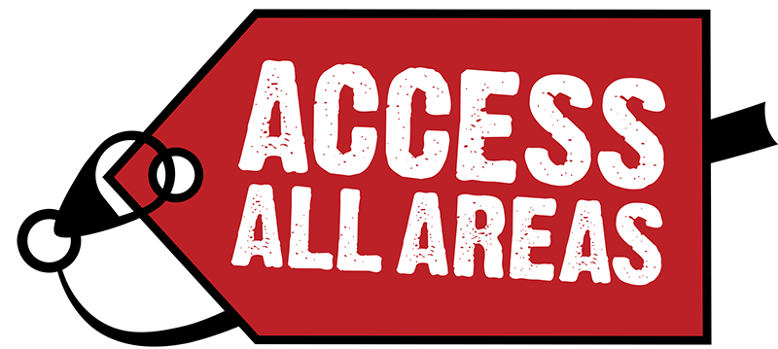
What is a visual guide?

A Visual Story Guide has
information and pictures to
prepare you for your visit to the
venue and performance.

If you have any questions about
the venue, please contact:

boxoffice@bushtheatre.co.uk

Bush Theatre
The Bush Theatre is a world-famous home for new plays and an internationally renowned champion of playwrights.
Jellyfish

Jellyfish is about a young woman with Down’s Syndrome and whether she has the right to love as they choose.

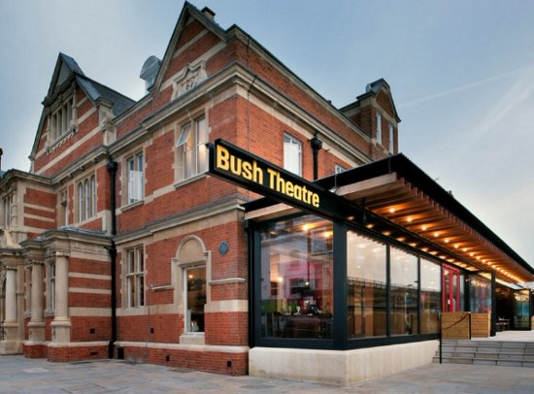  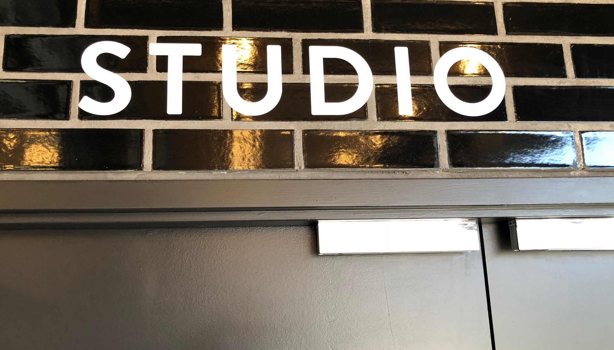 | Where is the performance taking place?  Bush Theatre  Which performance space?  Studio
Where is the Bush Theatre?

7 Uxbridge Road,
Shepherd’s Bush,
London, W12 8LJ
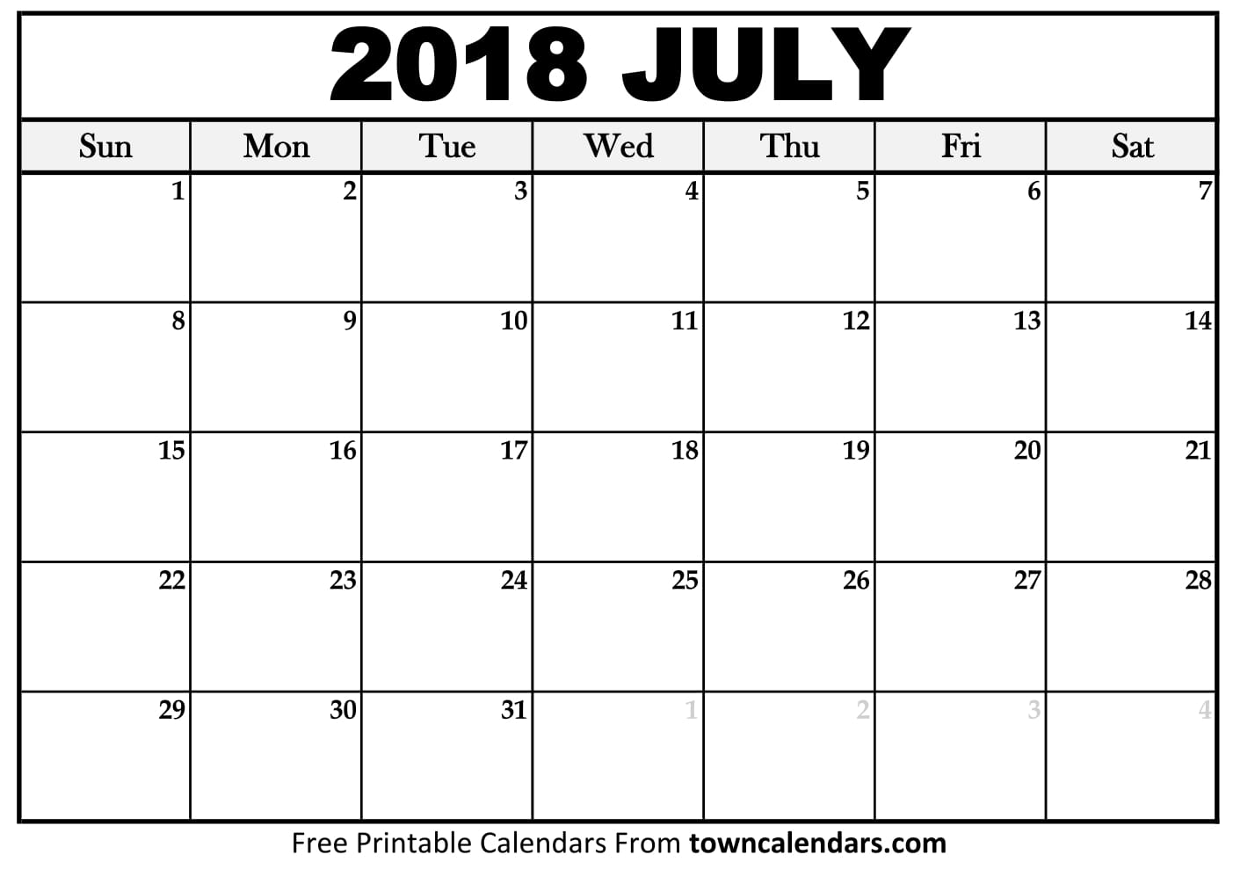  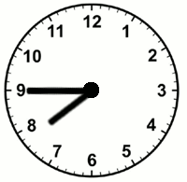  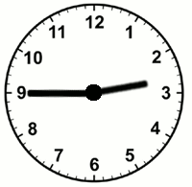 | When is the performance happening?  Performances will take place:  Monday 2nd July 2018  to  Saturday 21st July  What time is the performance?  Evening: 7:45pm  Matinee: 2:45pm
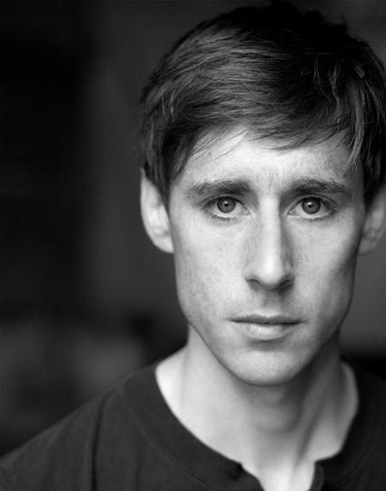 | Who is in the performance?  Sarah Gordy  Sarah plays Kelly  Nicky Priest  Nicky plays Dominic  Penny Layden  Penny plays Agnes, Kelly’s mum  Ian Bonar  Ian plays Neil

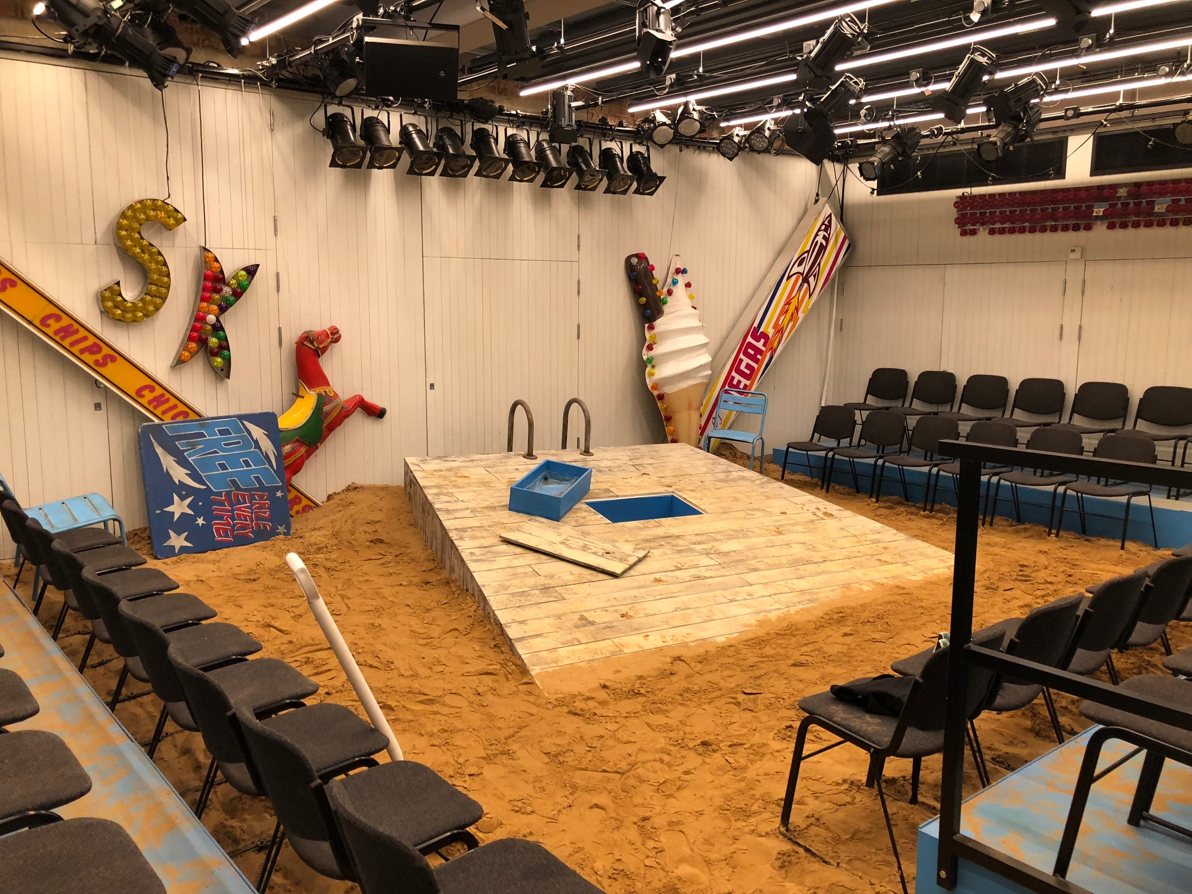 | What to expect in the performance?  Jellyfish is unreserved seating, which means you can choose your seat when you enter the Studio.  The stage is in the centre of the room and there is seating on 3 sides of the stage.
At some point, there will be:

- Music
- Beach and seagull sound effects
- Flashing lights
- Sand on the ground

You can cover your ears or use ear defenders.

Performance Information

- 2 hours 15 minutes
- 15 minute interval

If you leave during the show you will need to wait to go back in. The usher will let you back in.
You may finish later than expected
 | Here is a breakdown of each scene in the performance
Where is the performance set?

The performance is set in Skegness. Skegness is a town by the seaside.

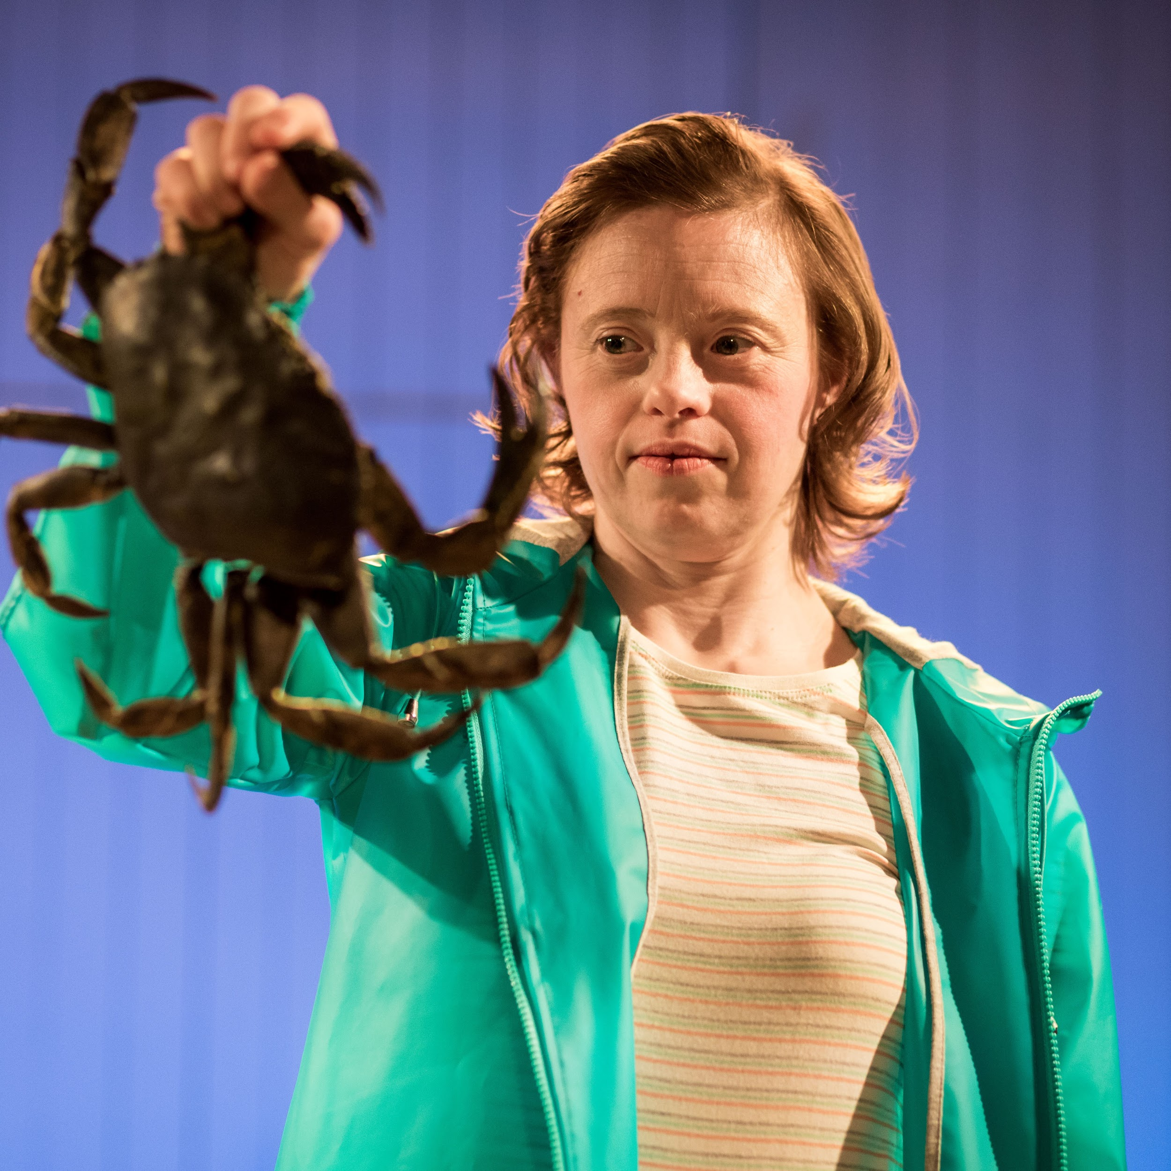 | Scene 1 - the beach  The performance starts on the beach.  Kelly and Agnes walk along the beach every day. Agnes is Kelly’s mum.  Warning  At some point Kelly will tie her shoe laces and Agnes will try and help her. Kelly will hit Agnes and Agnes will jump back and shout
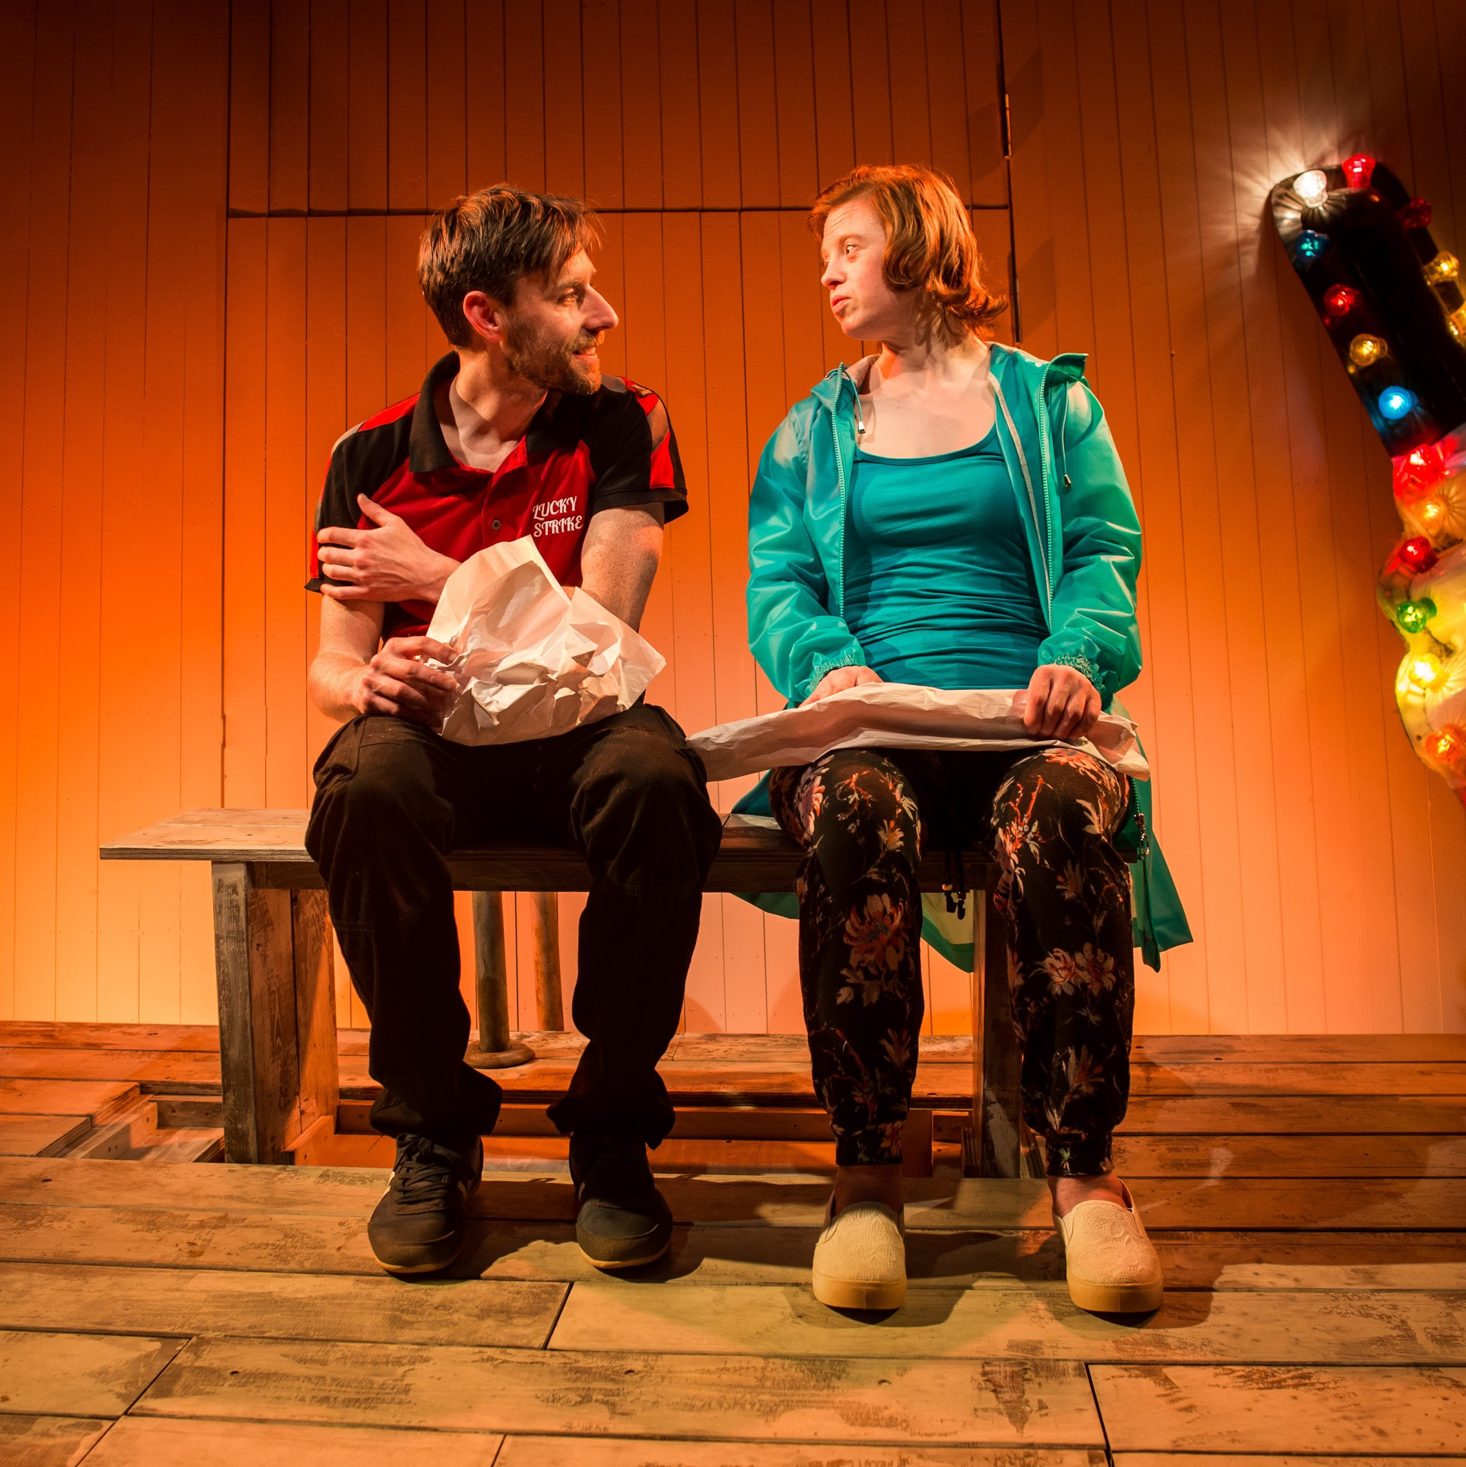 | Scene 2 - the beach  Kelly is sitting on a bench with Neil. They are eating chips/  Kelly and Neil fancy each other. Kelly wants to kiss Neil. Neil is nervous but in the end he kisses Kelly.
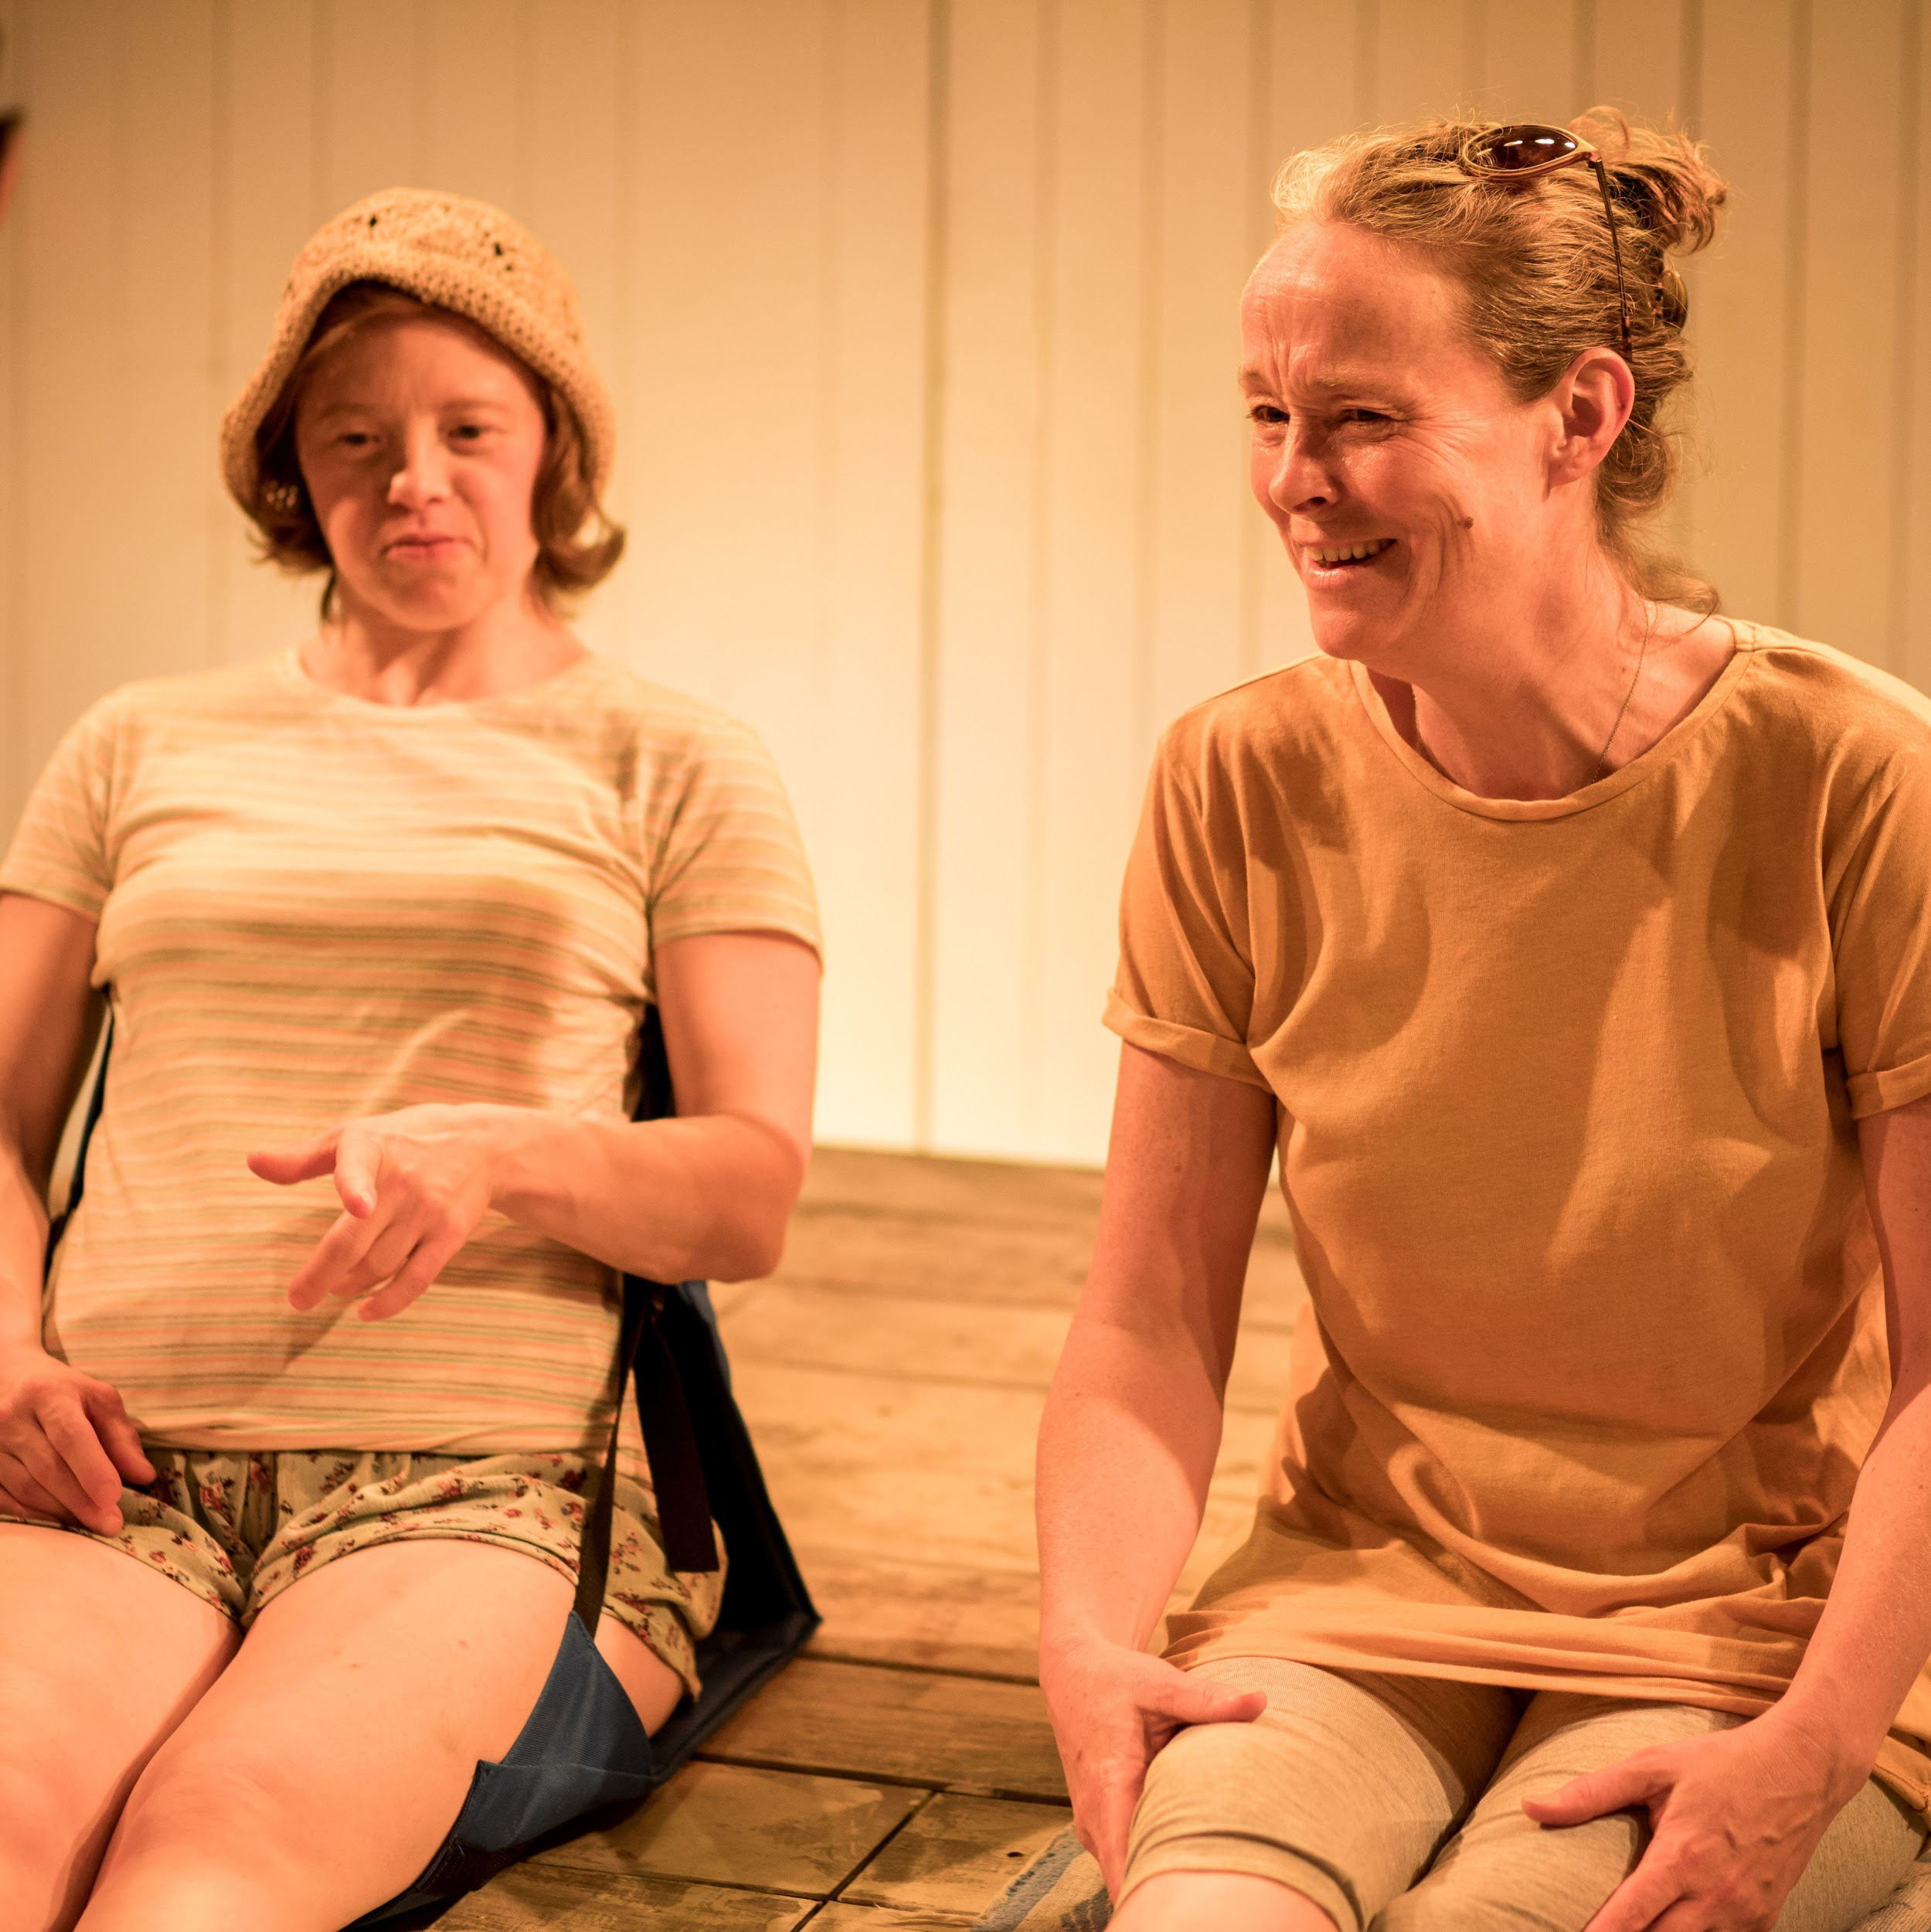 | Scene 3 - the beach  Kelly and Agnes are back at the beach.  Kelly’s phone keeps buzzing. It is Neil texting her.  Kelly tells Agnes about Neil. Agnes gets angry and worried.
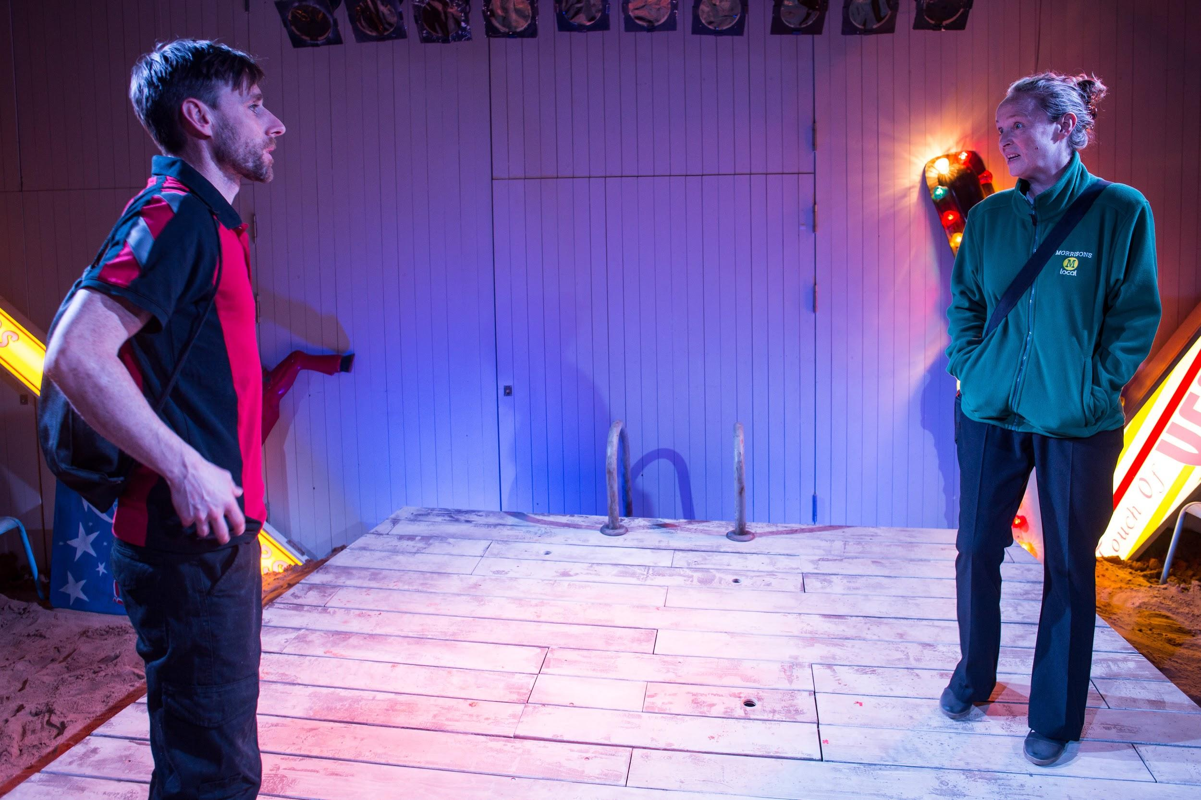 | Scene 4 - a car park  Agnes speaks to Neil in the car park outside the arcade.  Agnes is angry at Neil for kissing her daughter Kelly.  Agnes tells Neil he can not see Kelly anymore.
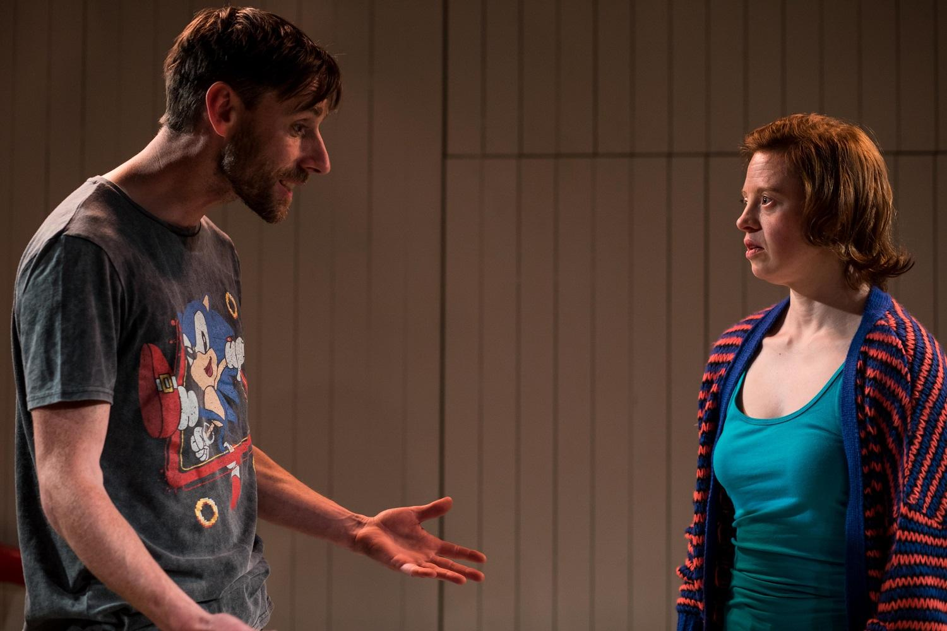 | Scene 5 - Seal Sanctuary  Neil and Kelly are at the Seal Sanctuary.  Neil tells Kelly they should not see each other again.  Kelly tells Neil that if he likes her, he is not allowed to leave her.
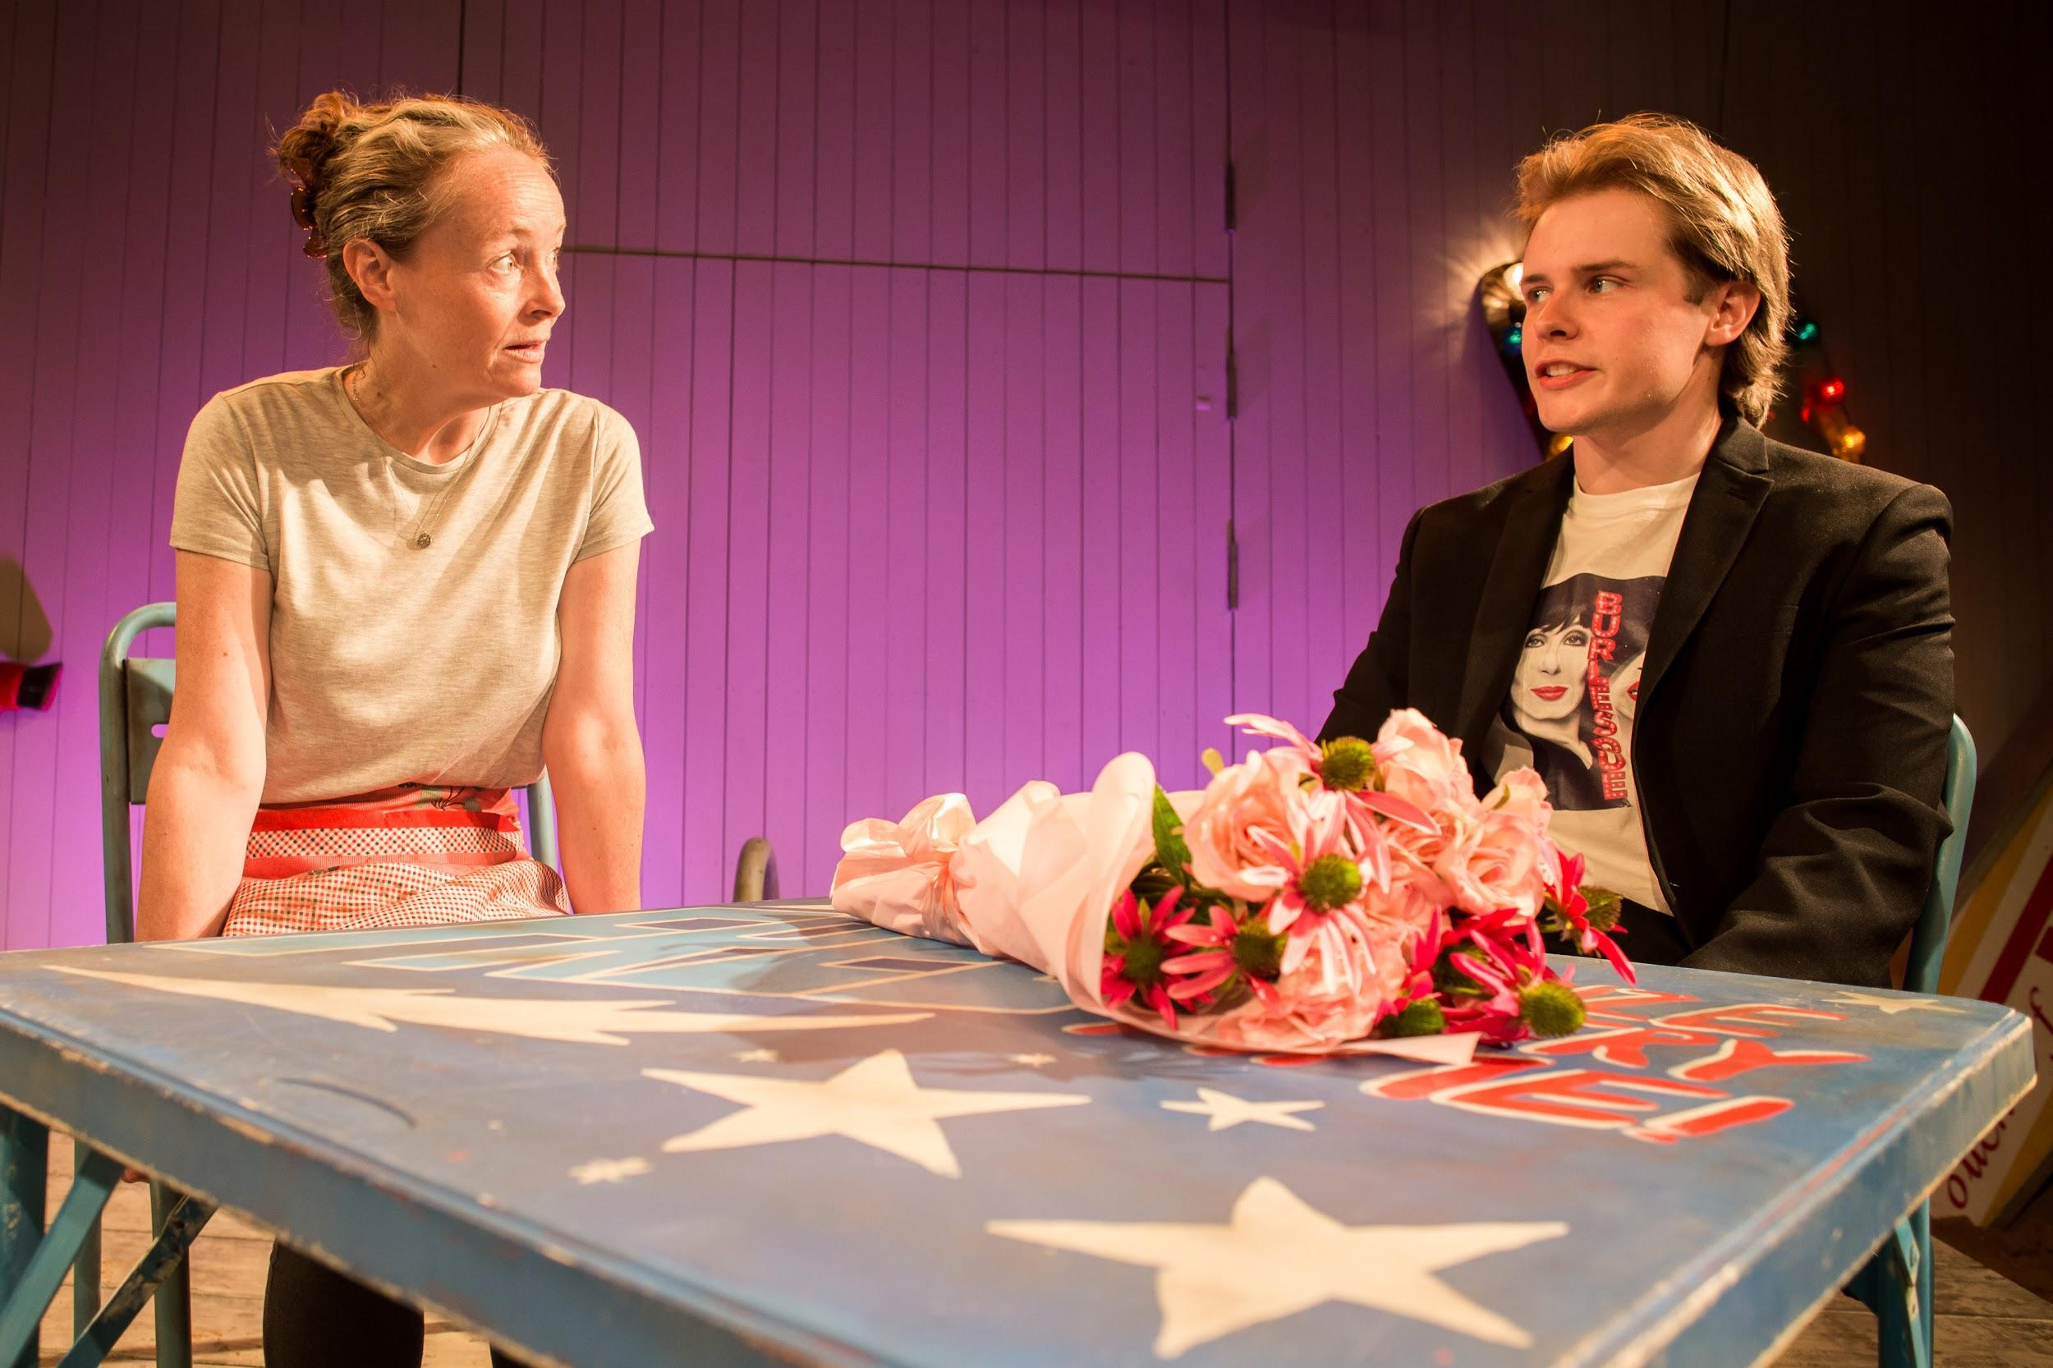 | Scene 6 - Kelly’s house  Agnes invites Dominic for dinner at Agnes and Kelly’s house.  Agnes wants Dominic to be Kelly’s boyfriend.  Kelly loves Neil, but becomes friends with Dominic.  Kelly tells Agnes that Neil is her boyfriend. Kelly tells Agnes that she is pregnant.  Kelly tells Agnes she is leaving home to live with Neil.  Warning  At some points Kelly will shout at Agnes loudly.
INTERVAL

The interval is 15 minutes.

The bar is at the front of the theatre

The toilets are upstairs
Scene 7 - the beach

Agnes, Kelly and Neil meet for the first time since Kelly moved out.

Agnes is angry at Neil. Kelly gets angry that Agnes and Neil are talking as though she is not there.

Warning

At some points Kelly will shout at Agnes loudly.

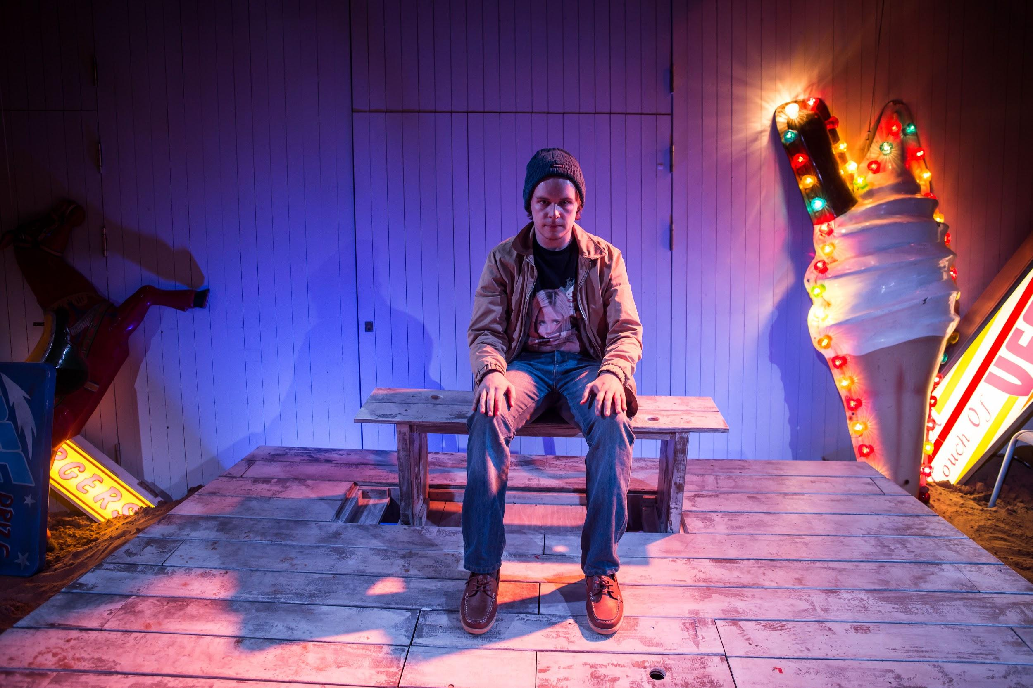 | Scene 8 - Agnes’s garden  Agnes and Dominic sit on a bench.  Agnes is throwing a party for Kelly’s birthday but Kelly has not arrived.  Agnes asks Dominic if he is sad that he was adopted.  Agnes asks Dominic if Kelly’s baby will be okay. Dominic says he does not know.  Neil comes into the garden and says Kelly is not coming
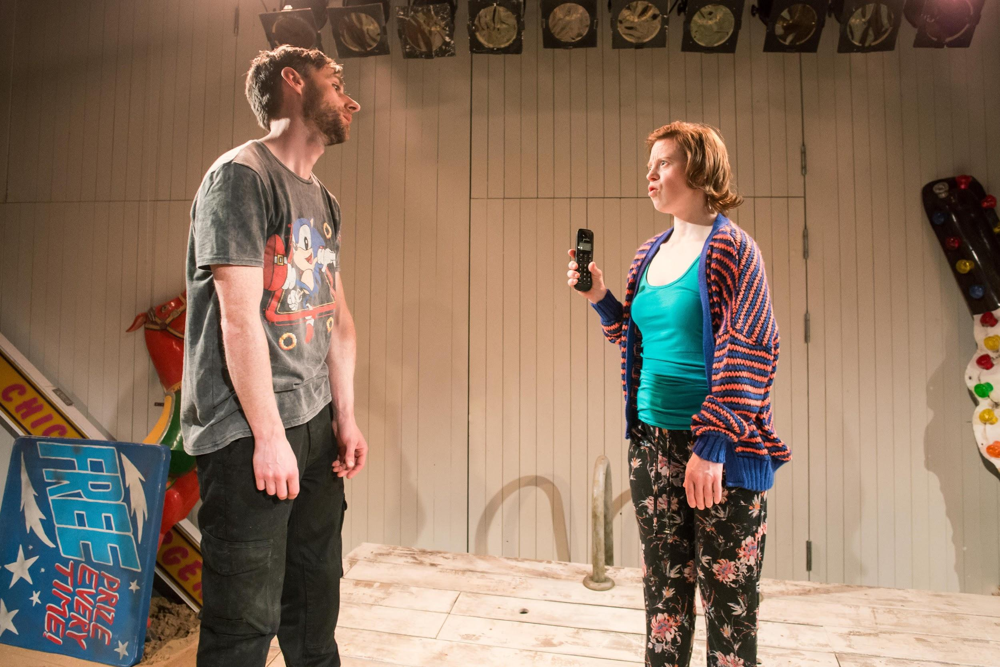 | Scene 9 - Kelly and Neil’s house  Kelly runs in. She is angry that Neil has been wanking and watching porn.  Kelly is worried that social services will take their baby away.  Neil tells Kelly that he has quit his job.  Kelly is even more worried and shouts at Neil.
Scene 10 - Agnes’s house

Agnes shaves Kelly’s legs.
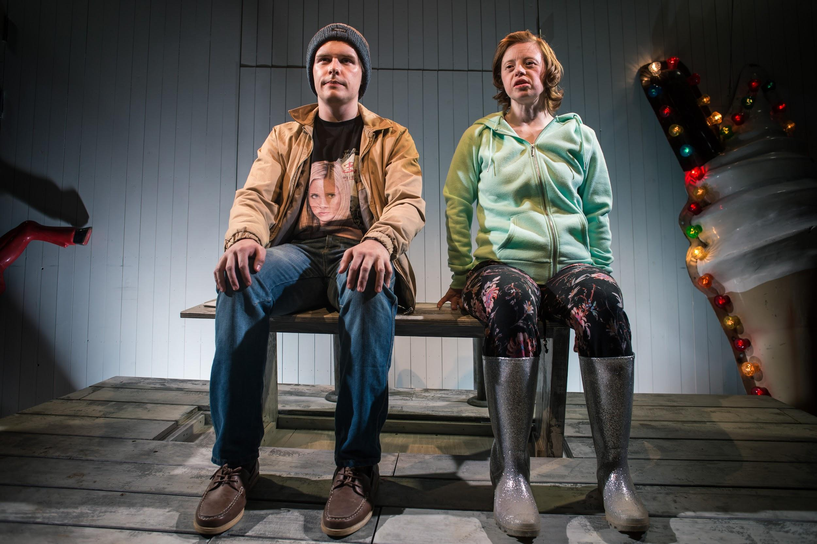 | Scene 11 - the beach  Kelly and Dominic are on the beach.  Dominic has found out he will be going on Mastermind. Mastermind is a TV quiz.  Kelly is reading questions out. Dominic tries to answer them.  Kelly tells Dominic he will do very well. Dominic tells Kelly she should talk to Neil.
Scene 12 - Agnes’s house

Kelly has just had a hospital test to see if her baby will have Down Syndrome.

Neil asks Agnes to be happier about the baby.

Agnes tells Neil that having a baby with Down Syndrome is hard.
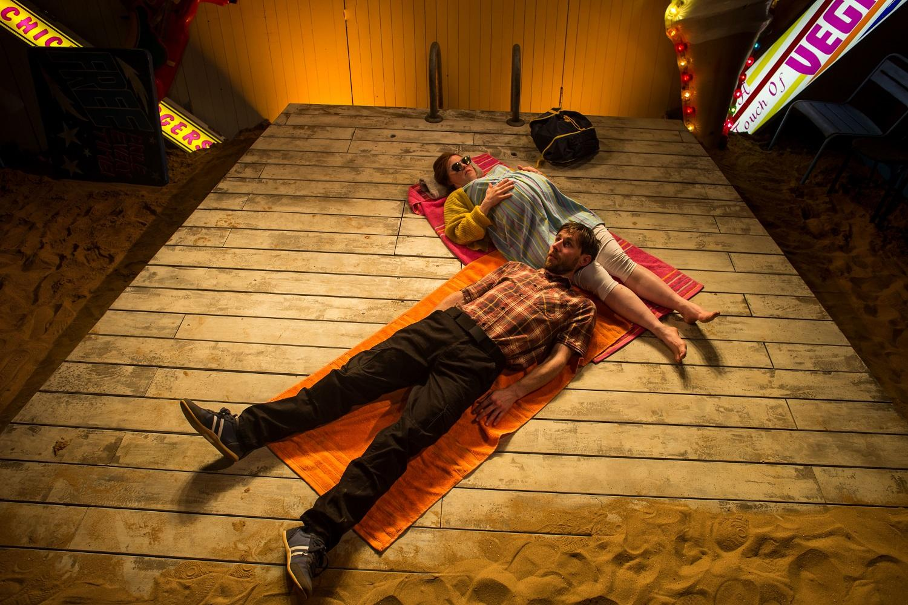 | Scene 13 - the beach  Neil and Kelly are on the beach.  Kelly gives Neil a piece of amber, because amber is rare and precious.  Kelly asks Neil to marry her. Neil says ‘yes’.
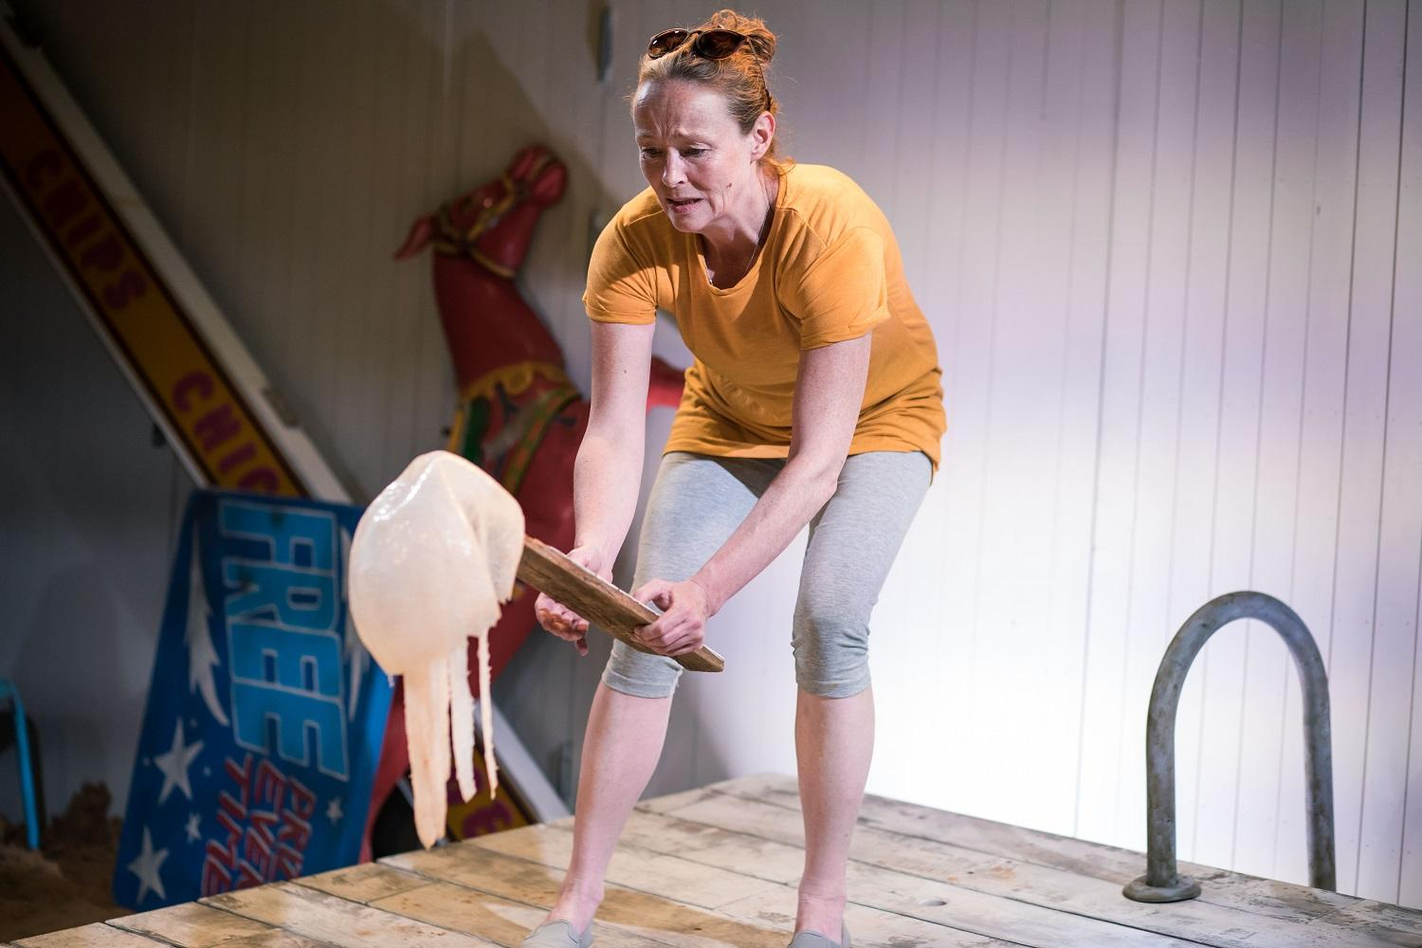 | Scene 14 - the beach  Agnes and Kelly are on the beach.  Kelly has just given birth to her baby.  They are going to visit Kelly’s baby in hospital.  Agnes tells Kelly about when Kelly was born.  Agnes and Kelly find a dead jellyfish.  Agnes tells Kelly she is proud of her.  Kelly says she will take good care of her daughter - just you watch!
Access

If you have any questions about access for this show, or if you need any help, please contact:

Call 020 8743 5050 to discuss your requirements.

If you have any questions about the show, please email

boxoffice@bushtheatre.co.uk

Thank you from

Bush Theatre

